**PROJECT REPORT**

**Bank Lending**

*Submitted towards the partial fulfillment of the criteria for award of Genpact Data Science Prodegree by Imarticus*

*Submitted By:*

*Ashish Patil*

*Vijay Paliwal*

*Zankar Sakharkar*

*Girish Motwani*

*Shubham Shinde*

*Course and Batch: DSP-22 Sept- 2019*



# Abstract

**Keywords**

*Disclaimer: *Data shared by the customer is confidential and sensitive, it should not be used for any purposes apart from capstone project submission for DSP. The Name and demographic details of the enterprise is kept confidential as per their owners’ request and binding.*

# Acknowledgements

We are using this opportunity to express my gratitude to everyone who supported us throughout the course of this group project. We are thankful for their aspiring guidance, invaluably constructive criticism and friendly advice during the project work. I am sincerely grateful to them for sharing their truthful and illuminating views on a number of issues related to the project.

Further, we were fortunate to have **Ravi Paul** as our mentor. He has readily shared his immense knowledge in data analytics and guide us in a manner that the outcome resulted in enhancing our data skills.

We wish to thank, all the faculties, as this project utilized knowledge gained from every course that formed the DSP program.

We certify that the work done by us for conceptualizing and completing this project is original and authentic.

Date: April 9, 2020

Place: Pune

# Certificate of Completion

I hereby certify that the project titled “Bank Lending” was undertaken and completed under my supervision by Ashish Patil, Vijay Paliwal, Zankar Sakharkar, Girish Motwani, Shubham Shinde from the batch of DSP (Sept 2019)

Mentor: Ravi Paul

Date: April 9, 2020

Place – Pune

Contents

Abstract 2

Acknowledgements 2

Certificate of Completion 3

CHAPTER 1: INTRODUCTION 5

1.1 Title & Objective of the study 5

1.2 Need of the Study 5

1.3 Business or Enterprise under study 5

1.4 Business Model of Enterprise 5

1.5 Data Sources 5

1.5 Tools & Techniques 5

1.6 Infrastructure Challenges 5

CHAPTER 2: DATA PREPARATION AND UNDERSTANDING 6

2.1 Phase I – Data Extraction and Cleaning: 6

2.2 Phase II - Feature Engineering 6

2.3 Data Dictionary: 7

2.4 Exploratory Data Analysis: 7

CHAPTER 3: FITTING MODELS TO DATA 8

3.1 LOGISTIC REGRESSION MODEL 8

3.1.1 First Logistic Regression Model 8

3.1.2 Second Logistic Regression model 8

3.2 RANDOM FOREST MODEL 8

CHAPTER 4: KEY FINDINGS 9

CHAPTER 5: RECOMMENDATIONS AND CONCLUSION 13

As per our findings we got 69% ~ 74% accuracy on 8.5 billion bias data. We can use logistic as well as random forest algorithm as per the user’s requirement. Many factors are required to check while applying the models such number of records, number of variables, co-relation, type of data used in data set etc. 13

# CHAPTER 1: INTRODUCTION

## Title & Objective of the study

* **Bank Lending data using python**

## Need of the Study

* **To understand bank lending process**

## Business or Enterprise under study

* **In depth learning for bank lending**

## Business Model of Enterprise

* **Analyzing the bank data by using multiple algorithm.**

## Data Sources

* Bank lending details- By Imarticus Learning Institute

## 1.5 Tools & Techniques

Tools:

* Python

Techniques:

* Pre-processing
* EDA
* Sampling
* Model building
* Cross validation

## Infrastructure Challenges

* Huge number of variables with skewed data
* Number of bias records
* To identify significant variable from large no of variables

# CHAPTER 2: DATA PREPARATION AND UNDERSTANDING

## 2.1 Phase I – Data Extraction and Cleaning:

* Missing Value Analysis and Treatment
* Handling Outliers
* Feature Extraction

## 2.2 Phase II - Feature Engineering

* Checked multi-collinearity by using heat map
* Created user define function to identify highly corelated variable
* Level merging
* Label encoding to standardized variables and **it** refers to converting the labels into numeric form to convert it into the machine-readable form
* Used stratified sampling for biased target variable

## 2.3 Data Dictionary:

## 2.4 Exploratory Data Analysis:

* Data Cleaning Processing
* Checking the variable type count in data
* Identifying the all unique values
* Dealing with Unique, or same value columns
* Counting the frequency of variables to check the biasness
* Dealing with all biased column.
* Drop all the columns having more than 75% of NA values
* For remaining columns Imputation according to data type
* Get numerical and categorial column separate
* Outlier analysis
* Discover outliers with mathematical function
* Rescaling Data
* Check for Correlation with Pearson Correlation to get all the Numerical Columns first with below code
* Split into test & train data

# CHAPTER 3: FITTING MODELS TO DATA

* **Logistic regression**
* **Random forest**

## 3.1 LOGISTIC REGRESSION MODEL

## 3.1.1 First Logistic Regression Model

## 3.1.2 Second Logistic Regression model

3.1.3 Model Validation

3.1.3.1 Checking for Variance inflation (Multicollinearity)

3.1.3.2. Fourth Linear Regression model

3.1.4 Predicting New Data

3.1.5 Comparison of Logistic Regression model

# 3.2 RANDOM FOREST MODEL

We applied Random Forest on the Training data set to validate if any further improvement of the model can be performed post the logistic regression.

# CHAPTER 4: KEY FINDINGS

Significant Variables identified in logistic models are also used in Random forest

Below table provides a snapshot of the various models which the business can choose from based on the pros and cons of each model.

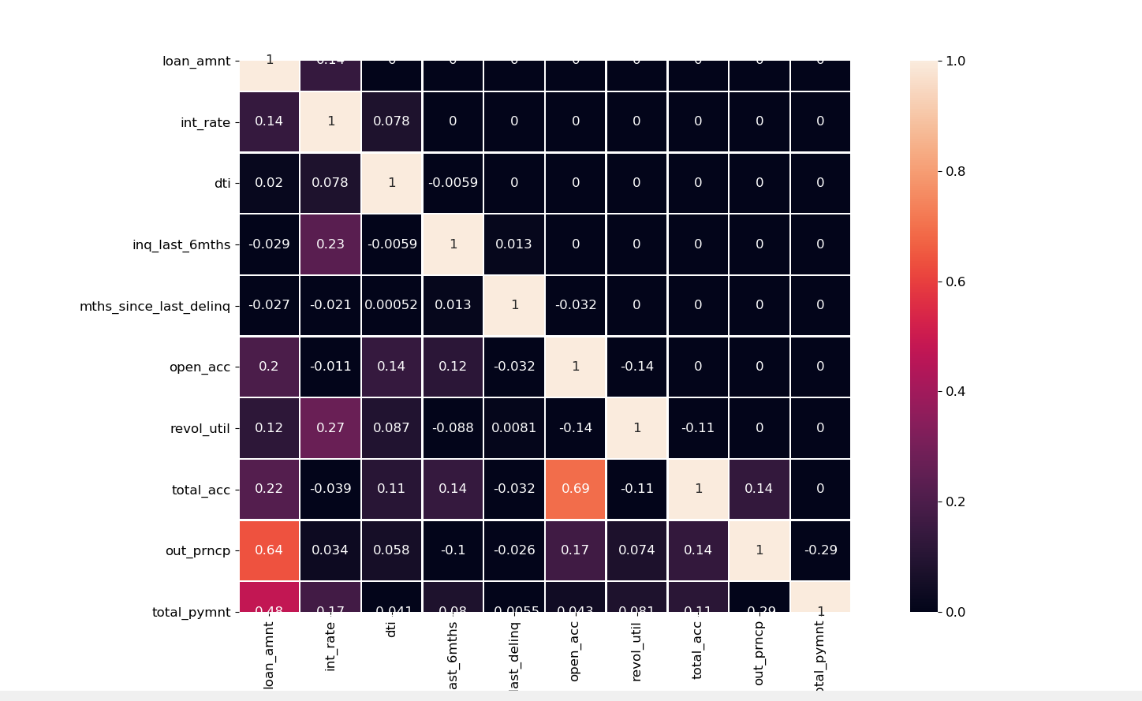

* **Logistic Regression:**

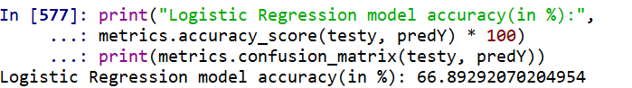

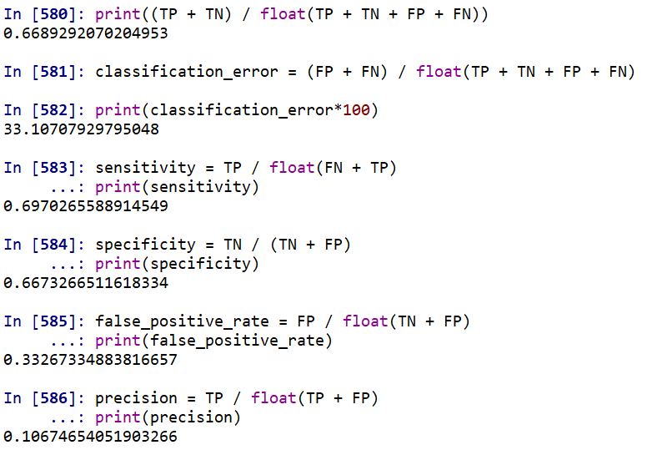

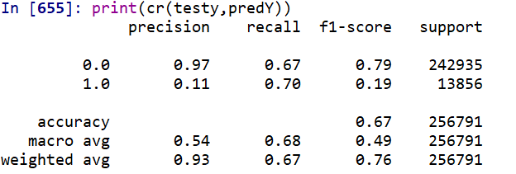



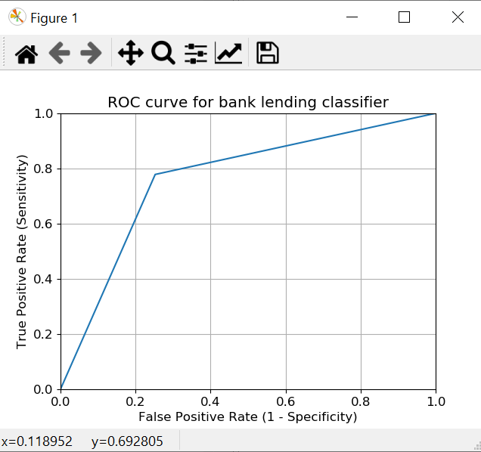

* **Random Forest:**

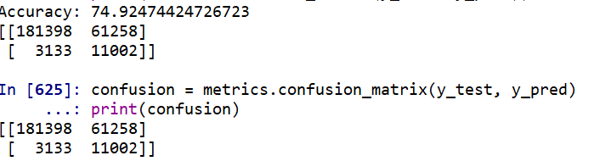

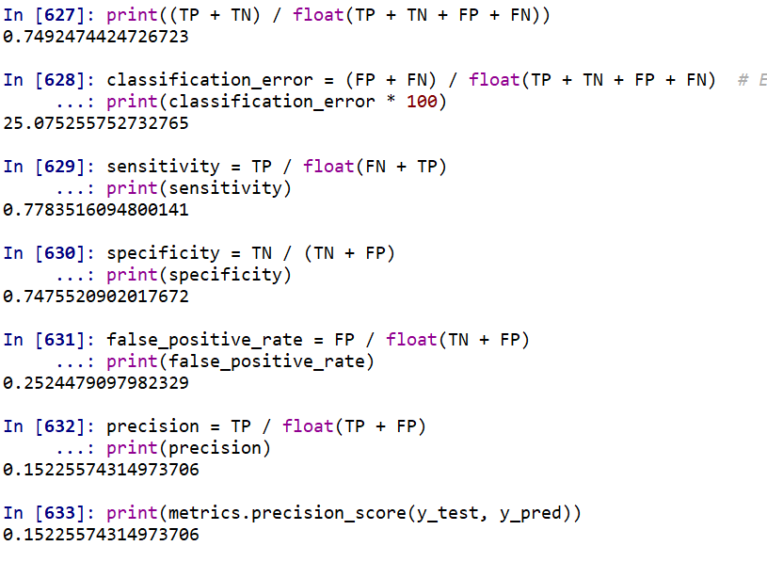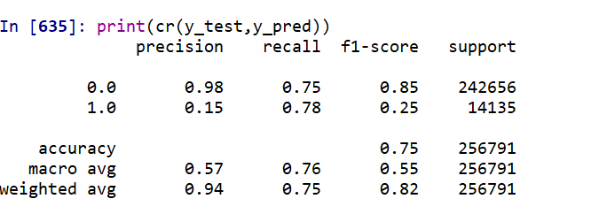

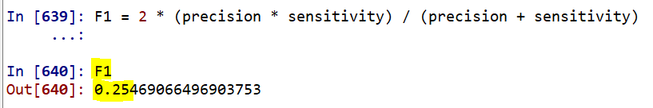



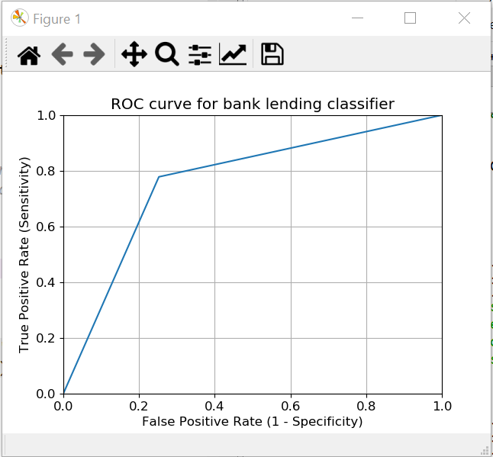

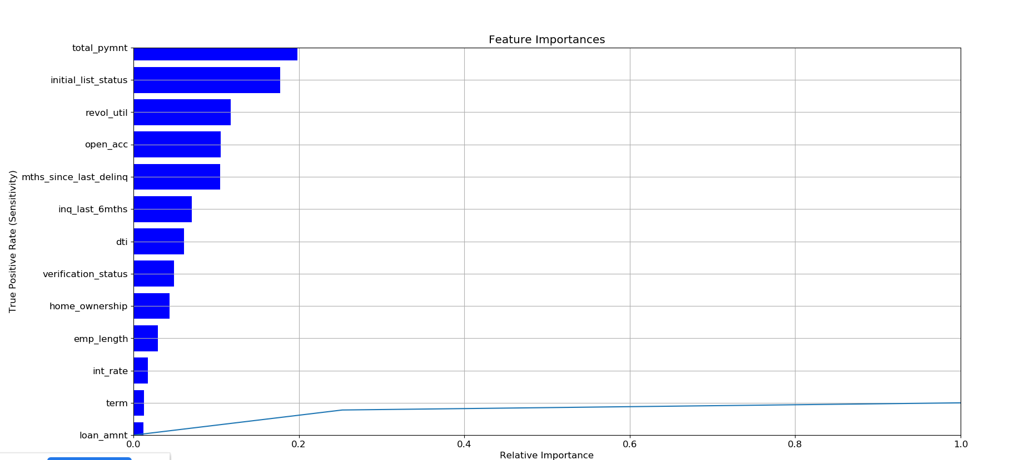

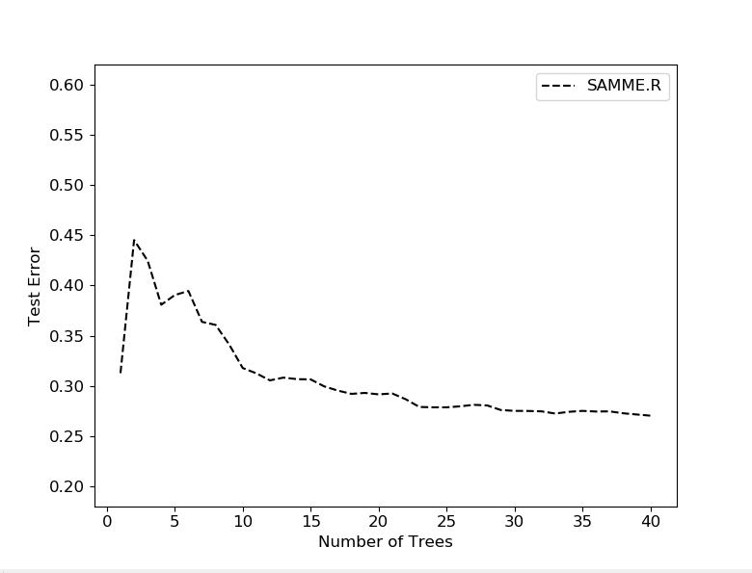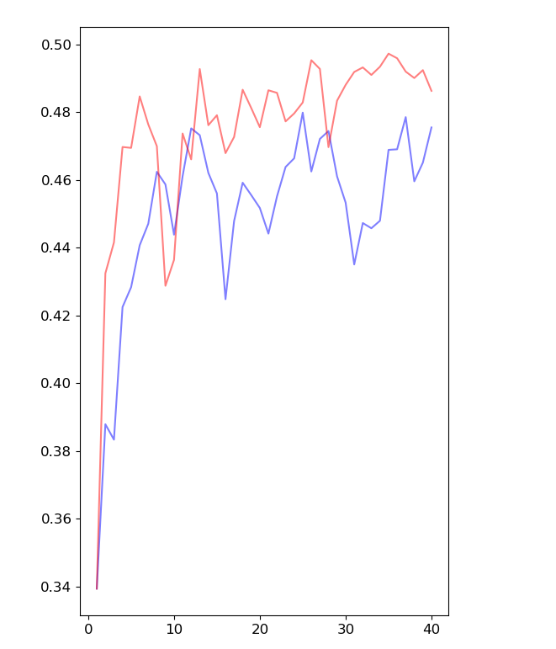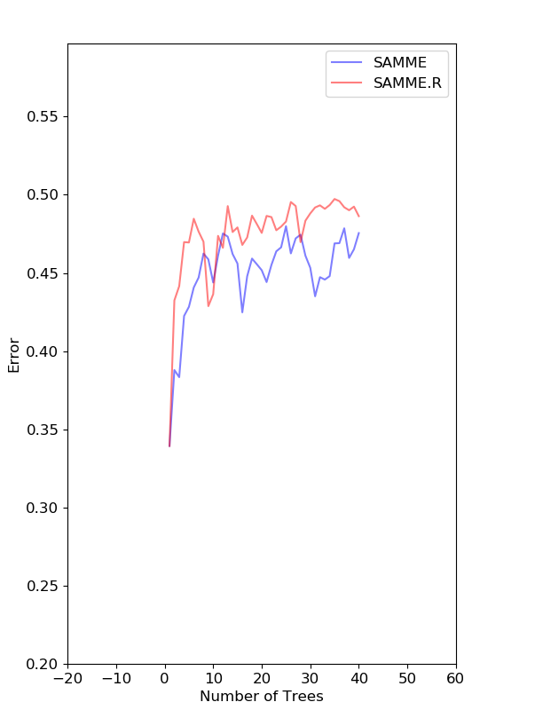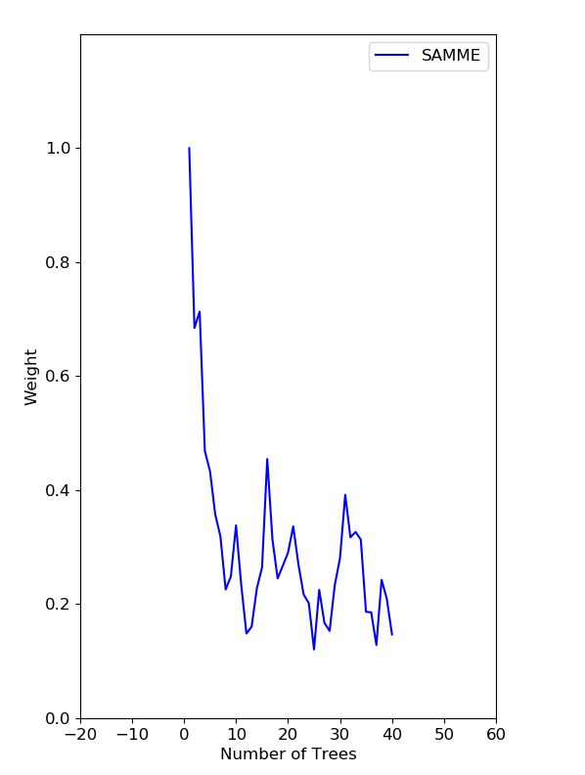

CHAPTER 5: RECOMMENDATIONS AND CONCLUSION

As per our findings we got 69% ~ 74% accuracy on 8.5 billion bias data. We can use logistic algorithm to get the best fit model. Appling of Random forest algorithm on the same data set, would get precise accuracy with +/- 10%. Many factors are required to checked while applying the models such number of records, number of variables, co-relation, type of data used in data set etc.